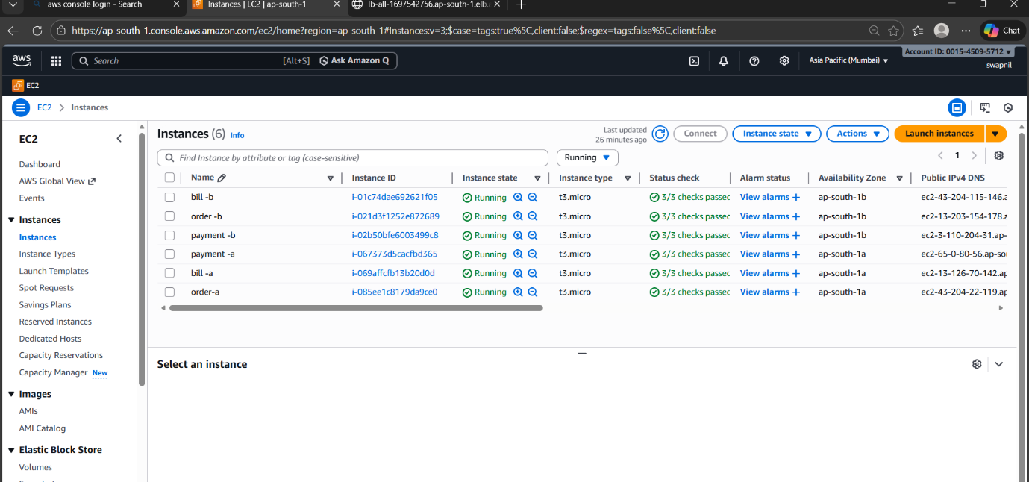
Step 1 create Ec2 instances
Zone A __ homepage, payment, bill, order
Zone A __ homepage, payment, bill, order

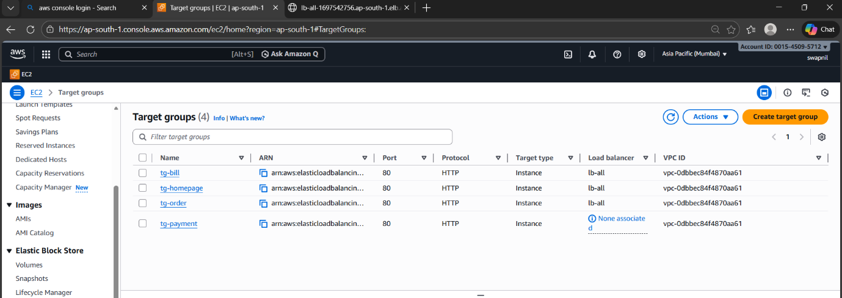

Step 2 create target group
Tg - homepage
Tg - bill
Tg - payment
Tg – order

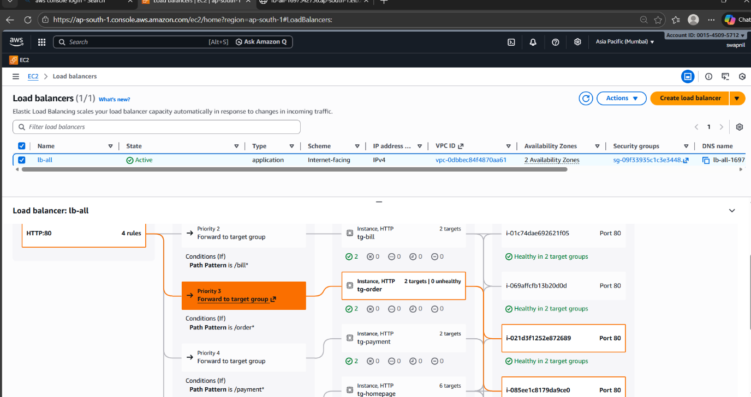
Step 3 create load balancer and add rule for tg - bill, payment, order

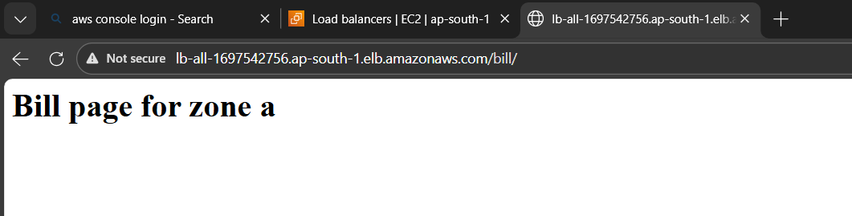
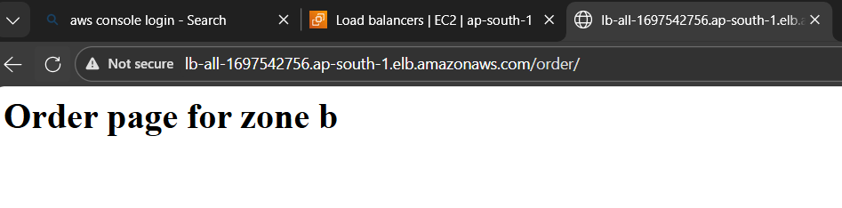
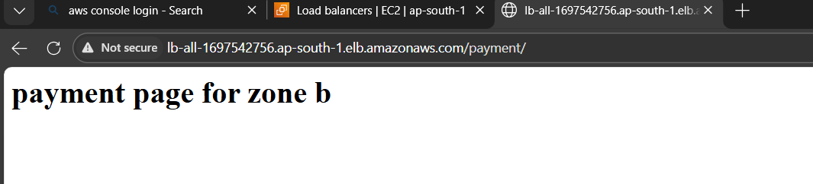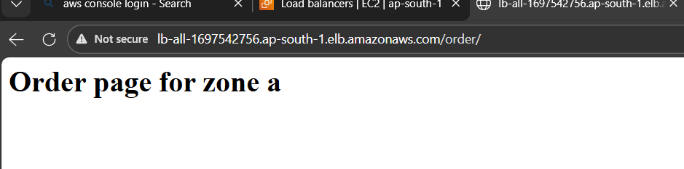

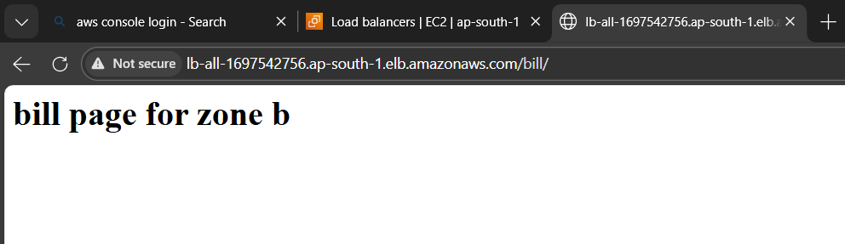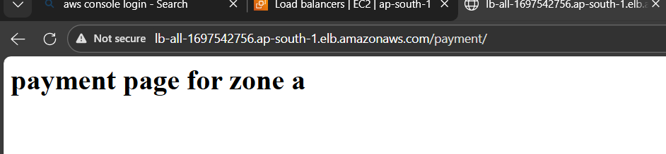
Step 4 access website _ result

